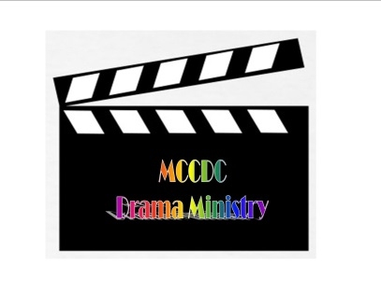
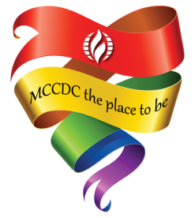

Dear LGBTQ+ Supporter,

Hello! My name is Jules Christian and I am the Drama Ministry Leader at the Metropolitan Community Church of Washington DC. We are a Christian Church, specifically ministering to the LGBTQ+ community, assembled by people from all backgrounds, faith traditions and walks of life.

In May, the MCCDC Drama Ministry will be hosting its first Dinner Theater fundraiser, featuring an original play, that supports the rights and obstacles of our community. The play takes place in Modern Day DC, and we are looking for sponsors to help fund this project.

As a pro LGBTQ+ person/business, you have this exciting opportunity to be involved! We are seeking monetary and/or in kind donations. All of our sponsors will be recognized as follows:

Bronze=$200.00 or less:
Your Name/Your Business Name listed in our program.

Silver=$201.00-$500.00:
A large Ad with Your Name/Your Business Name listed in our program,
and online ad

Gold=$501.00-$1000,00:
A full page ad featuring Your Name/Your Business Name and Logo,
an online ad, + 2 complimentary Tickets to the show.

Platinum= $1001.00 or more:
Your Name/Business Name/Product featured in the play,
A full page ad featuring Your Name/Your Business Name and Logo,
an online ad, + 4 complimentary Tickets to the show.

MCCDC is a 501C3 Non-Profit Organization, and all donations are tax deductible.
To make a donation, set up a meeting, or for more information, please contact Rev. Jules Christian at: enjoyingtoday@hotmail.com or 336-419-7579. Checks can also be mailed to:

MCCDC Drama Ministry
Rev. Jules Christian
474 Ridge Street NW
Washington DC 20001

Please make checks payable to: MCCDC with Drama Ministry Dinner Theater in the subject line. Thank You for supporting the MCCDC Drama Ministry!

