Learning To Walk In The Dark
What if it is while we are in the dark, that we grow the most?

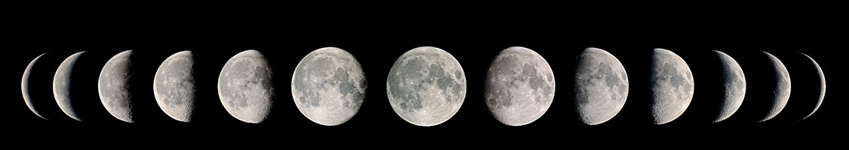

We cannot live in a world that is interpreted for us by others. An interpreted world is not a hope. Part of the terror is to take back our own listening. To use our own voice. To see our own light - Hildegard of Bingen
.

Welcome and Opening Ourselves:
Psalm (CEV)
How much longer, God, will you forget about me?
Will it be forever? How long will you hide?
How long must I be confused and miserable all day?
How long will my enemies keep beating me down?
Please listen, God, and answer my prayers.
Make my eyes sparkle again, or else I will fall into the sleep of death.
My enemies will say, “Now we’ve won!”
They will be greatly pleased when I am defeated.
I trust your love, and I feel like celebrating because you rescued me.
You have been good to me, God, and I will sing about you.

Covenant:
- I will be open to hearing new truths and new possibilities.
- I will actively listen, even if I do not share the same perspective, in case God is opening me to a new revelation.
- I will pass if I am uncomfortable with sharing and will allow others to do the same without judgement.
- I will use I statements, as I can only speak for myself.
- I will not interrupt when someone else is speaking.
- I will not interpret when someone else is speaking.
- I will be brief when sharing to allow others an opportunity to share.
- I agree to keep confidential others stories, as they are not mine but theirs to share
- I agree that two opposing viewpoints can both be true

Guided Meditation:

Close your eyes and settle into a quiet, interior, space within …

Now, take a moment to note anything you felt, heard, sensed, or saw that brought you insight, clarity, or peace …

Introspection

I have courted the Beloved long enough to know what it is like to receive a divine visit: It is like being held by someone with all the time in the world, it is like remembering a dream that opens a door. Earlier in my life, I wanted more specificity than that. I wanted a divine parent who would give me direct answers, clear guidance, specific tasks. Now that I have accepted responsibility for supplying those things myself, it is enough to step away from them time to time, resting in the presence of the Beloved who accepts all answers, covers all directions, finishes all tasks.
- Reflect on a time when you received a divine visit, what was it like?

- Remember a time when you allowed yourself to rest in the presence of the/a Beloved. What do you remember about the encounter?

- What does it mean to your faith journey to accept responsibility for supplying your own answers, clear guidance and specific tasks?

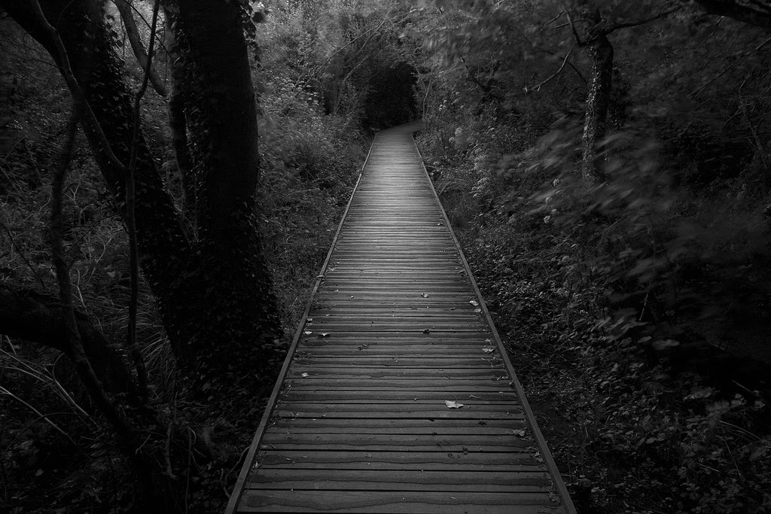
Back to the Beginning

Tonight, it is possible to accept this peaceful darkness as a token of the divine presence, but what about the frightening night? When darkness comes not as a friend but as a threat, then what? In the absence of any sense of God, I wish I had known that it is still possible to trust God.

- When you read the word “trust,” what images, feelings, or thoughts come to your mind?

- What does it mean to you to trust the divine presence?

- Have you ever experienced peaceful darkness?

- How do you practice trust, when the darkness is frightening?

Table Sharing >

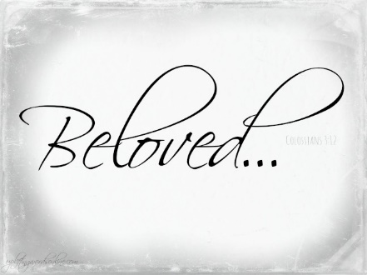
Whom did I refuse to let in that night? Did I turn the Beloved away because of a frightening mask? Or was the Beloved out there without a mask for once, asking only that I handle my fear long enough to let the divine darkness in?
How many times since then have I rejected Love because it did not present itself the way I expected, in a form acceptable to me? I do not know that either. All I know is that I am as rested as I have ever been after my short night in this cloud of unknowing, where I let the darkness manage me for once instead of trying to manage the darkness.

After reading the quote aloud in your table group, please take turns sharing EITHER:

- What are ways we turn a dark thing into a bad thing?

- What would it mean to you to rest in a cloud of unknowing?

- Share what it would mean to you to allow darkness to manage you instead of you managing it.

- Share how fear of the dark may have stopped you from engaging the divine presence.

Going Deeper >

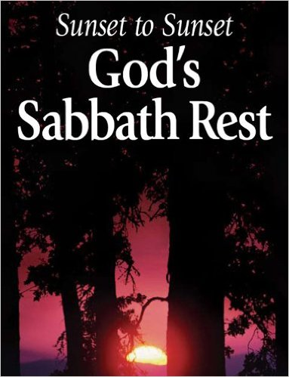
And yet the Sabbath is never only about the Bride (the moon). When she appears, it means the wedding can begin. When she comes through the door, everyone in her presence becomes as rich in God’s love as she is. She is the mirror, not the light. As beautiful as she is, she is this night’s reminder of every other night like this, when the last day of the week lies down in the grass so the new day of God’s own rest can begin – not with light but with darkness.
And there was evening and there was morning, the seventh day.
In the book of Genesis, darkness was first; light came second. Darkness was upon the face of the deep before God said anything. ….All I know is that darkness was not created, it was already there, so God’s act on the first day of creation was not to make light and darkness but to make light and separate it from darkness, calling the light “day” and the darkness “night.”
- How would our imaging change with our congregation, if we embrace God resided in the darkness before light was created?
- What would it mean to us as Christians, if we embraced the understanding that a Sabbath begins with the dark instead of the light?

- What would it mean to us as Christians, if we embraced the understanding that a new day begins with the endarkenment?

Group discussion>

Living into lunar spirituality and endarkenment allows us the freedom to embrace those feelings, things and ideas that resonate as true to our spirit and reject those feelings, things and ideas that injury our souls. If it is true that darkness may save us, and we embrace endarkenment as we have the light, how would your life, faith and way of being shift as we consider…

- Darkness is as important to my understanding of God as is light.

- Darkness was first.

- There is much to learn from a lunar spirituality.

- There are things you can only learn in the dark.

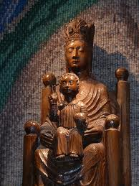
Affirmation:
Looking back and forth between the two light shows in front of me, I understand the choice I am being offered: do I want the kind of light that shines on things or the kind of light that shines from them? The next morning I stop by the cathedral gift shop to buy the silver medal with Our Lady of the Underground on it.
All must come through me in order to live in the lights.
Our Lady of the Underground never asks me to choose between night and day. If I want to flourish, I need the ever-changing light of darkness as much as I need the full light of day.
Give your heart to them both, she says.

Closing:

The soul does not grow by addition but by subtraction…

Leave place, leave time,

Avoid even image!

Go forth without a way

On the narrow path,

Then you will find the desert track.

Meister Eckhart

….become more curious about your own darkness…….

Resource created by Rev. Vickey Gibbs

