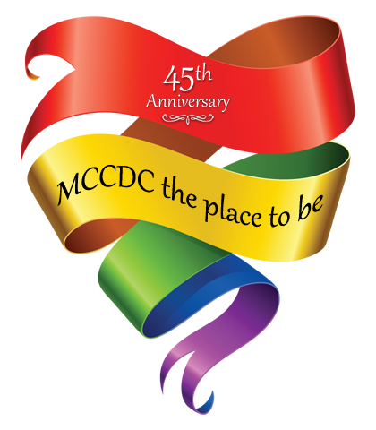

May 21, 2016
7-10 pm
MCCDC 45th Anniversary Dinner Program Booklet

An evening of Dining, Dancing, Silent Auction and Celebrating

National Press Club
529 14th St. NW, 13th Floor
Washington, DC

May 15-17 2014
The DoubleTree by Hilton Hotel Atlanta North Druid Hills-Emory Area
2061 N. Druid Hills Rd NE
Atlanta, Georgia, 30329

For hotel reservations:
USATEL: 1-404-321-4174
FAX: 1-404-419-805

Souvenir Program Ad Request Form
CONTACT INFORMATION (One form per ad, PLEASE PRINT LEGIBLY)
Name:
Organization/ Church Name(s):
Street Address:
City/State/Zip:
Contact Telephone:
Email:
SOUVENIR PROGRAM BOOK AD RATES (You will be contacted later regarding ad production details)
Inside front cover |  |  | $500
Back cover |  |  | $400
Inside back cover |  |  | $300
Full-page ad |  |  | $250
Half-page ad |  |  | $125
Quarter-page ad |  |  | $75
Business card |  |  | $50
4-line text greeting (black text) |  |  | $25
TOTAL FOR PROGRAM BOOK AD(S): |  |  | $ _____
Payment Methods:  -mccdc.com/donate  -Please mail check along with accompanying form to: MCCDC office  -Kiosk in Church Welcome Hall  -Cash brought to the MCCDC Church Office |  | Submission Instructions:  EMAIL TO: Mr. Quanti Davis cue971@gmail.com  FAX TO: MCCDC 202-638-4048  MAIL TO: MCCDC; ATTN: 45th Anniversary Team  474 Ridge Street NW  Washington, DC 20001  202-638-7373  Submission deadline April 22nd
Please sign here to confirm this order:
For more information regarding sponsorships and program ads, contact:
Mr. Quanti Davis at cue971@gmail.com or 301.275.1393

Ads are in color.
No bleed on any ad.
Unless 4 line written ads are selected, ads must be provided as high resolution files.
Resolution 300dpi @ 100%
Quarter Page
4.875 x 3.625
Horizontal Half Page
7.5” x 5.875”
1/8 Page
3.625” x 2.313”
Full Page
7.5” x 10”

